EXPERIMENT 4

AIM:
MATLAB Simulation of Superheterodyne Receiver for AM Communication System with Frequency Mixing and Filtering

SOFTWARE REQUIRED:
MATLAB Simulink

PROGRAM:
Clc; clear; close all;
Fs=1e5;
T=0:1/fs:0.02;
Fc=10000;
Fm=1000;
fLO=15000;
m=0.5*cos(2*pi*fm*t);
AM=(1+m).*cos(2*pi*fc*t);
LO=cos(2*pi*fLO*t);
IF=AM.*LO;
Out=abs(hilbert(IF));
Out=out-mean(out);
Plot(t,AM,’b’,t,IF,’r’,t,out,’g’);
Legend(‘AM Signal’,’IF Signal’,’Output’);
Xlabel(‘Time’); grid on;
Title(‘Superheterodyne Receiver’);

OUTPUT:
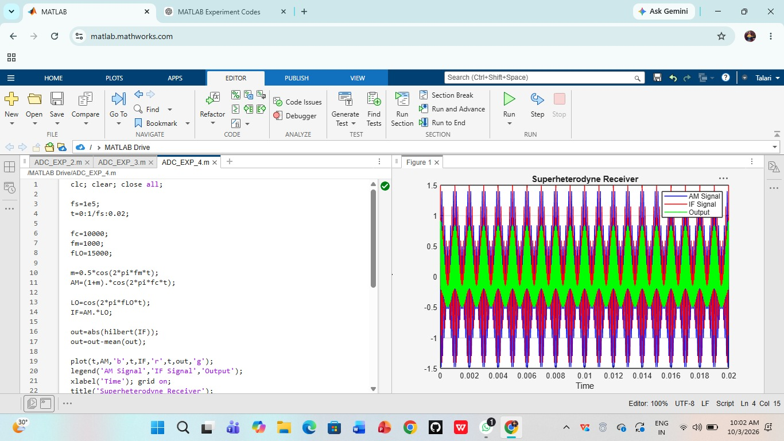

RESULT:
Thus, the operation of a superheterodyne receiver using frequency mixing and filtering was successfully demonstrated using MATLAB.

